Aidan Fischer

CS 564 Midterm

3/23/2024

I pledge my honor that I have abided by the Stevens Honor System

* Create Search
  + Basic Course
    - 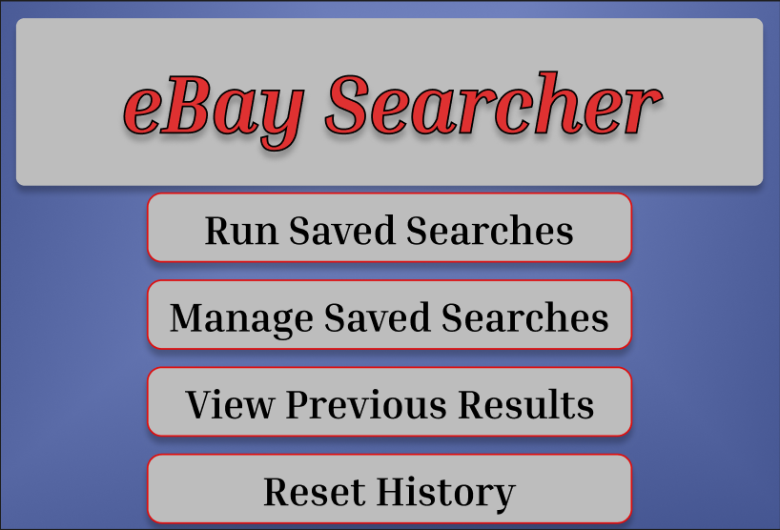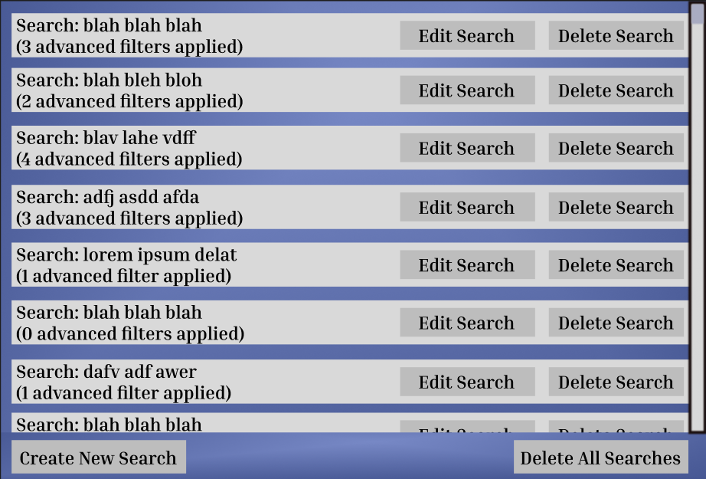The User hits the “Manage Saved Searches” button.
    - The system runs the “View Saved Searches” Use Case.
    - 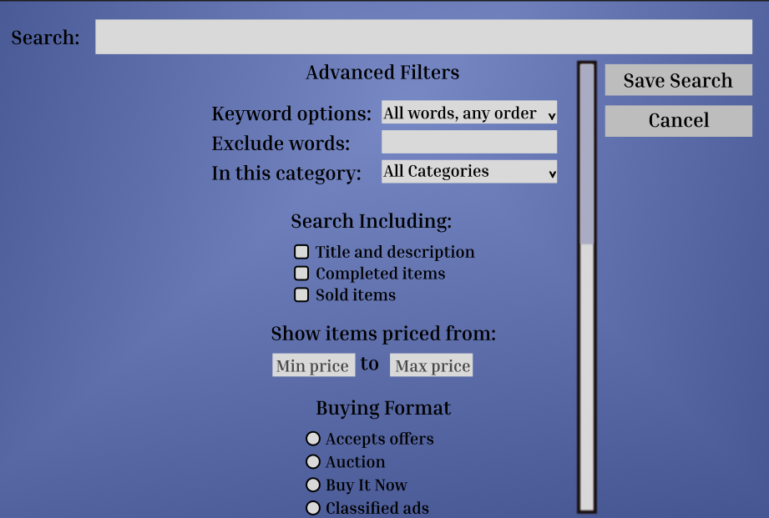The User hits the “Create New Search” button. The system displays the search creation window.
    - 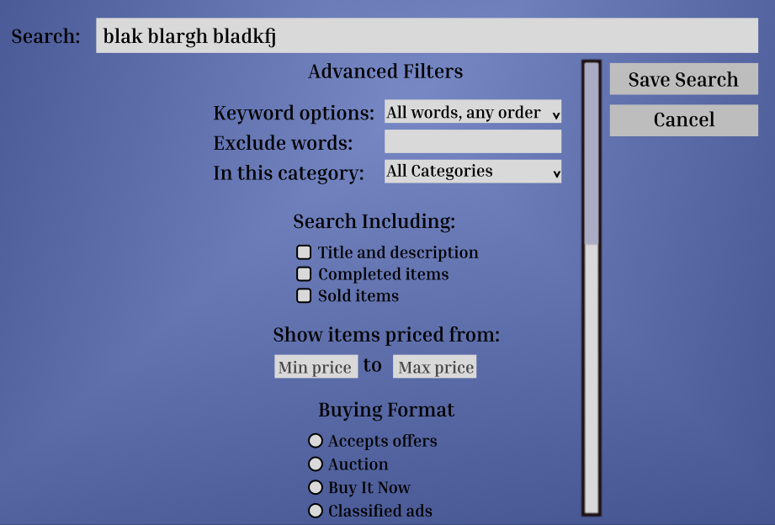The User enters the search term(s) for a basic search.
    - 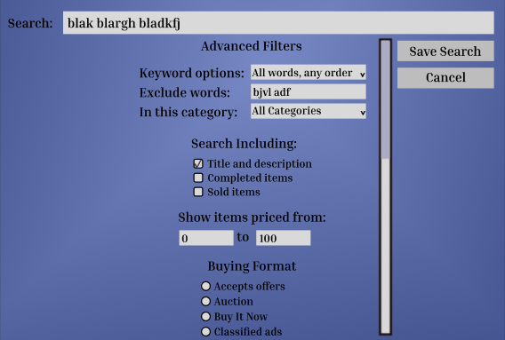The User optionally defines one or more advanced search parameters.
    - The User hits the save search button. The system saves the search to the internal database and returns the user to the main window.
  + Alternate Courses
    - 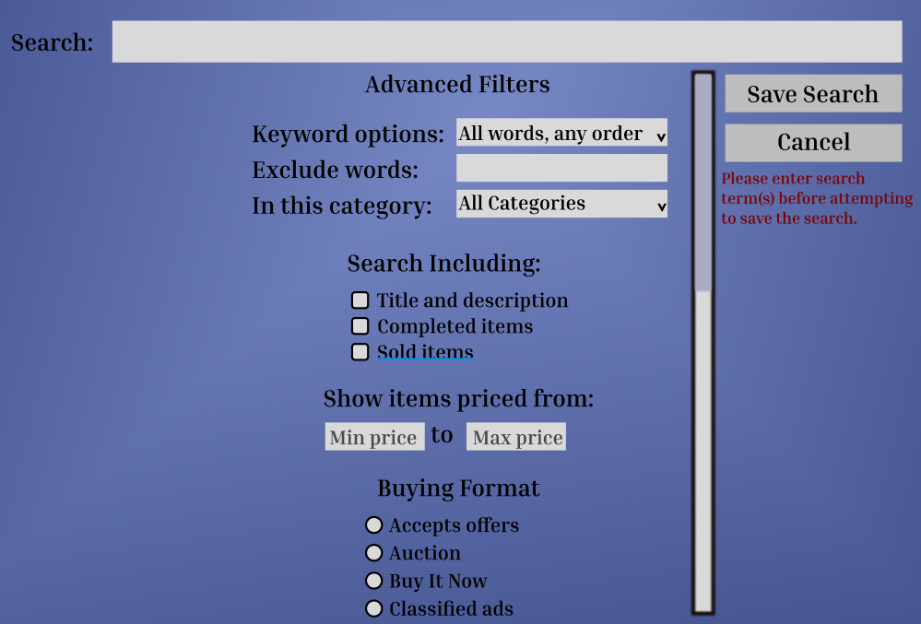If the user does not enter a search term, the system displays a message to that effect and does not save the search.
    - If the user hits the Cancel button, the system discards the search and returns to the main window.
    - 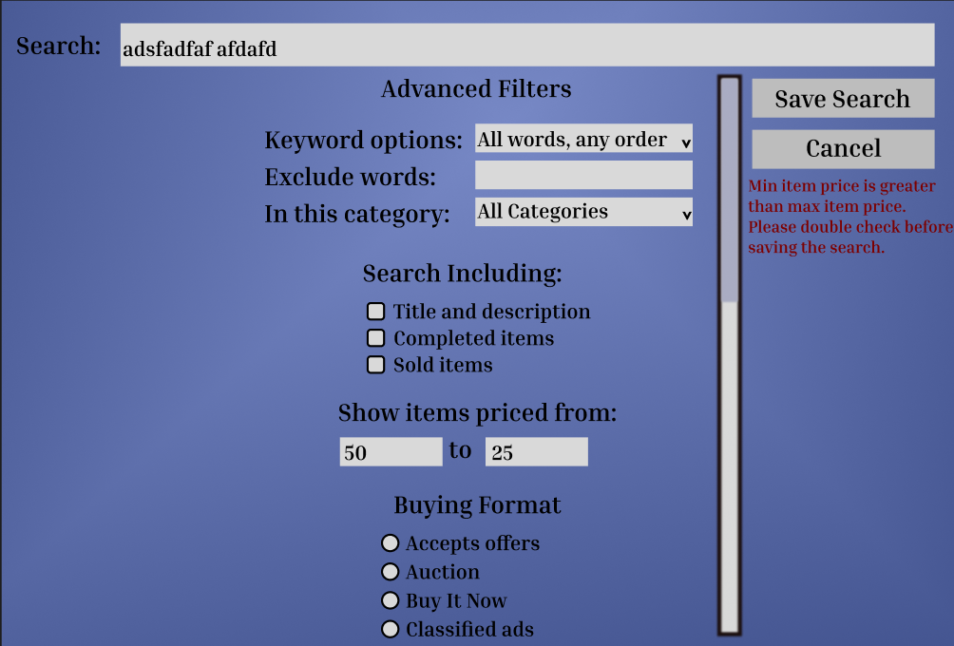If, in the advanced “price” parameter, the min price is greater than the max price, the system displays a message to that effect and does not save the search.
    - 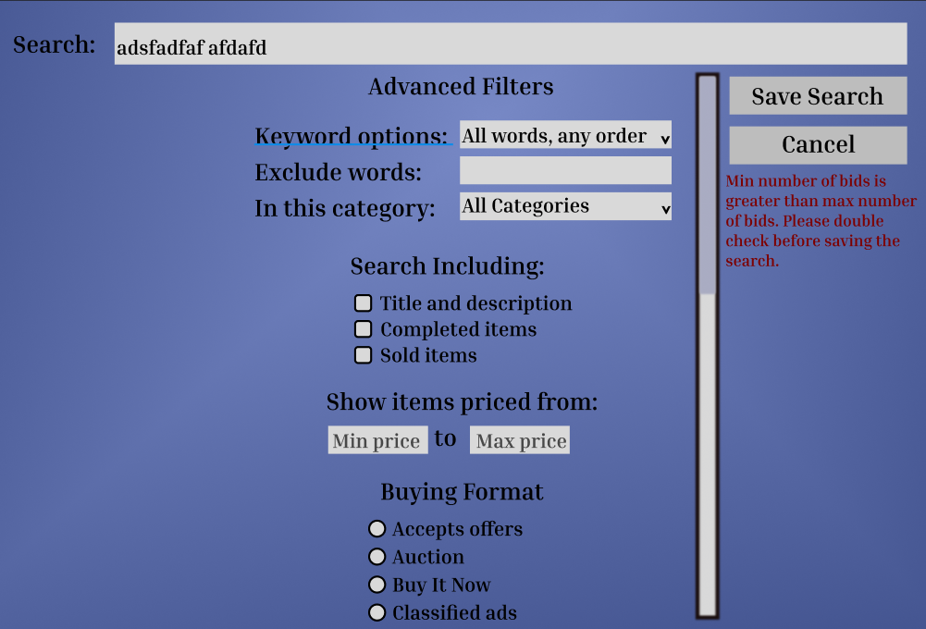If, in the advanced “number of bids” parameter, the min number is greater than the max number, the system displays a message to that effect and does not save the search.
    - 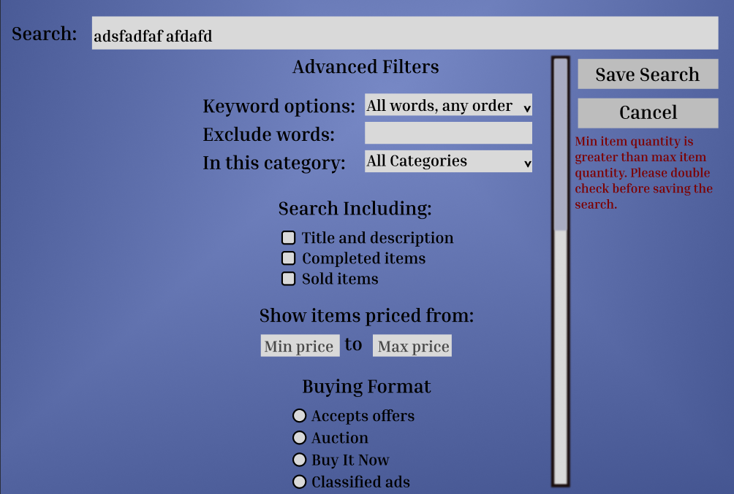If, in the advanced “quantity” parameter, the min quantity is greater than the max quantity, the system displays a message to that effect and does not save the search.
    - 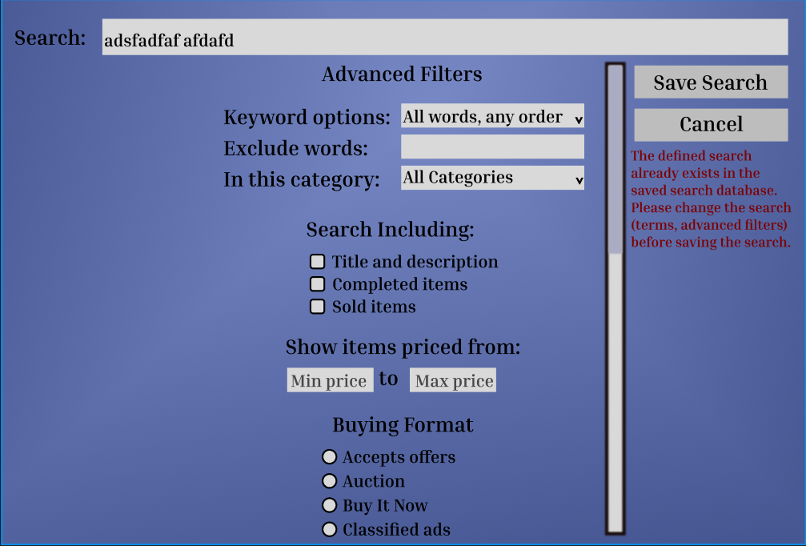If the search already exists (equality based on both terms AND all applied advanced parameters), the system displays a message to that effect and does not save the search.
* View Saved Searches
  + Basic Course
    - The user hits the “Manage Saved Searches” button.
    - The system loads all saved searches and displays a window containing basic information about all searches.
  + Alternate Course(s)
    - 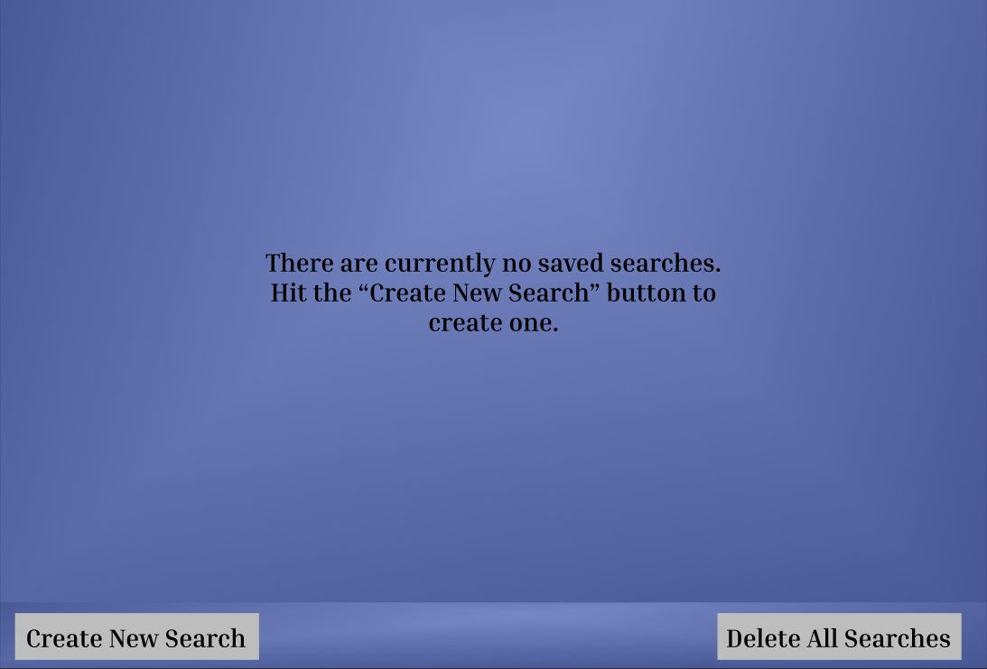If no searches are currently saved, the system still displays the window but displays a message to that effect in the window.
    - 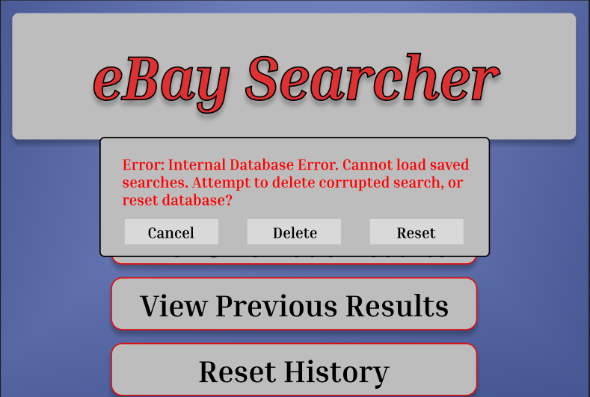If there is an internal error with the database, display a message to that effect and request if the user wants to attempt to delete the offending search or reset the database.
* Edit Saved Searches
  + Basic Course
    - The user hits the “Manage Saved Searches” button.
    - The system runs the “View Saved Searches” Use Case.
      * 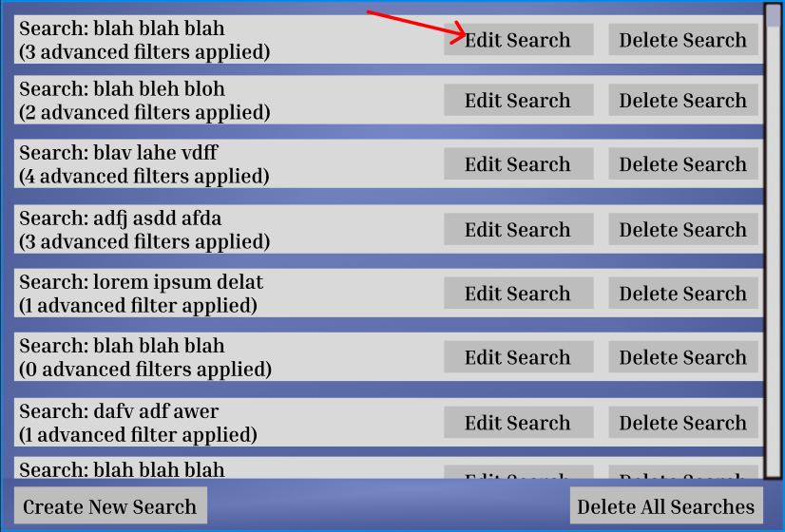The user scrolls to a specific search. The user hits the “Edit Search” button attached to the intended search.
    - 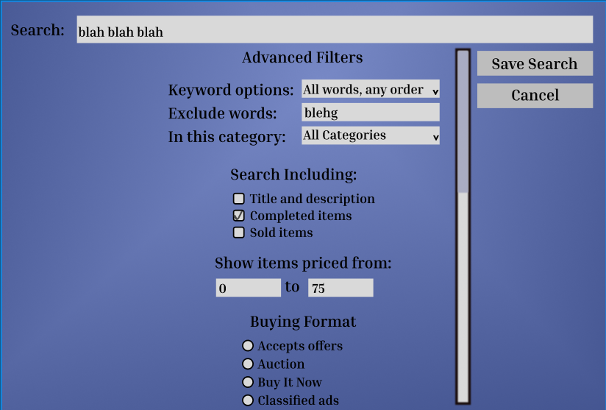The system takes the user to the “Create Search” Use Case with the search’s current information prefilled.
    - 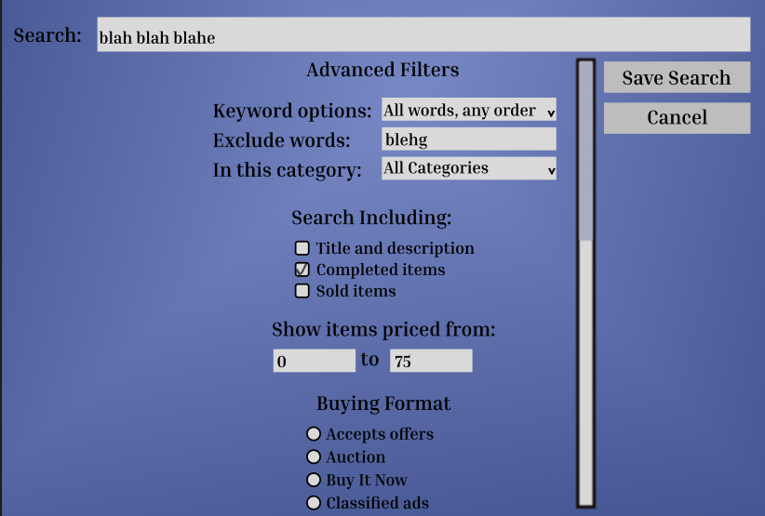The user edits the search.
    - 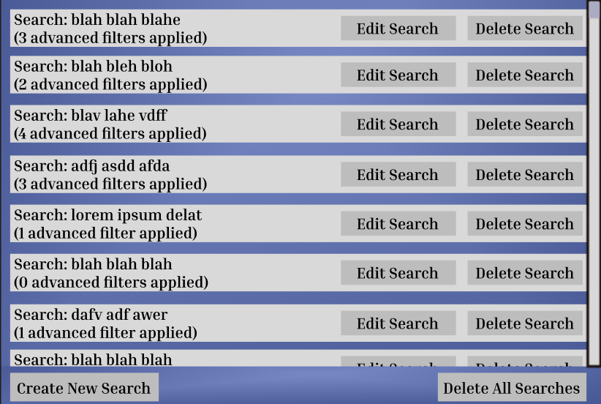The user saves the search. The system saves the edited search with the new information and the window is reloaded.
  + Alternate Course(s)
    - 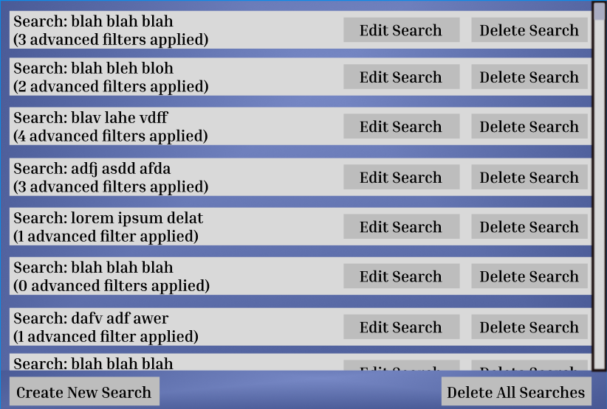If the user hits “Cancel” during the editing, the system will discard the edits and leave the search unchanged.
* Delete Saved Searches
  + Basic Course
    - The user hits the “Manage Saved Searches” button.
    - The system runs the “View Saved Searches” Use Case. The user scrolls to a specific search.
    - 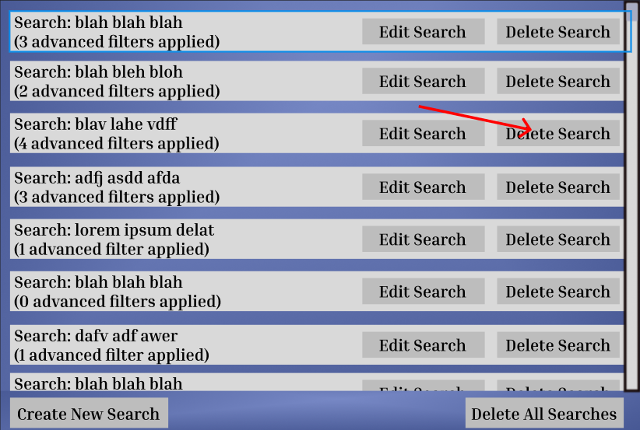The user hits the “Delete Search” button attached to the intended search.
    - 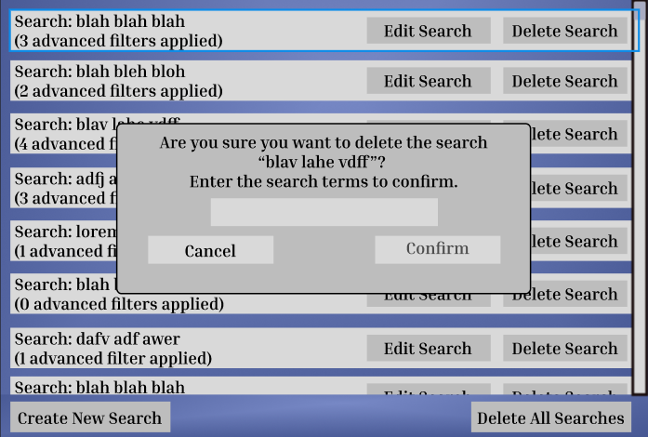The system displays a confirmation dialog.
    - 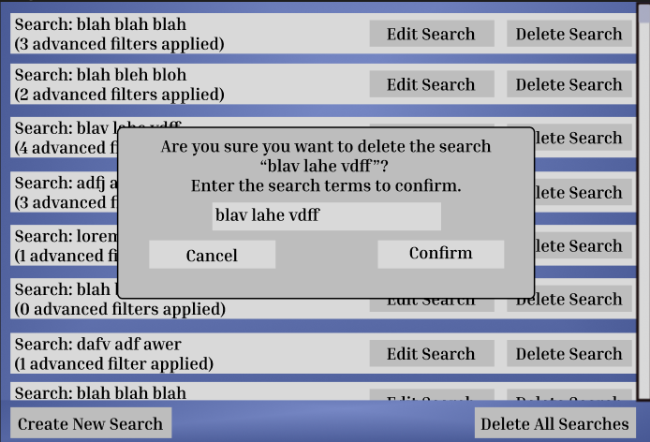The user enters the search terms and hits “Confirm”.
    - 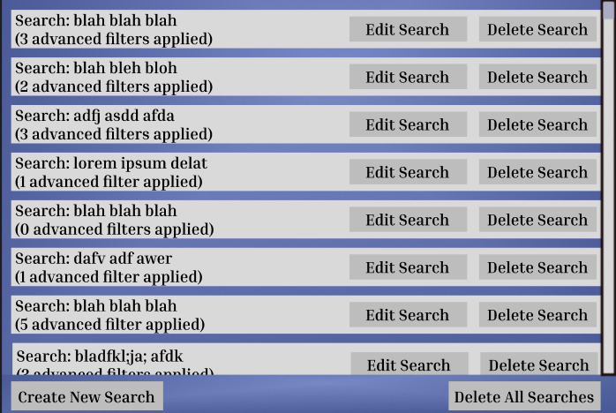The system deletes the search from the internal database and reloads the window.
  + Alternate Course(s)
    - 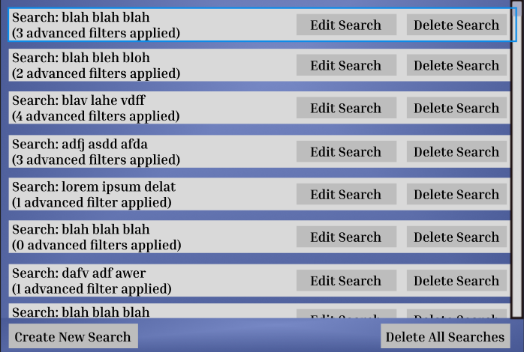If the user hits “Cancel” in the confirmation dialog, the system does not delete the search.
* Delete All Saved Searches
  + Basic Course
    - The user hits the “Manage Saved Searches” button.
    - The system runs the “View Saved Searches” Use Case. The user hits the “Delete All Searches” button.
    - 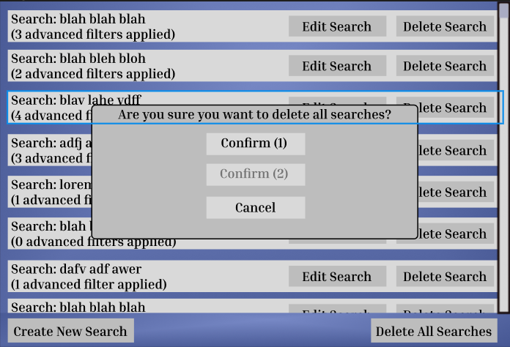The system asks the user for confirmation twice.
    - The user confirms both times. The system deletes all searches and reloads the window.



* + Alternate Searches
    - If the user does not confirm twice, do not delete all searches.
* Run Searches
  + Basic Course
    - 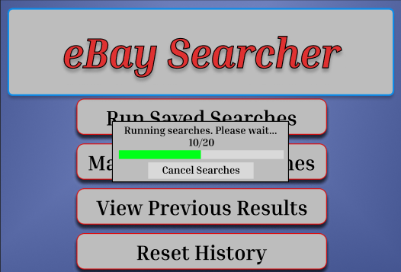The user hits the “Run Searches” button. The system begins contacting the eBay website with the saved searches.
    - 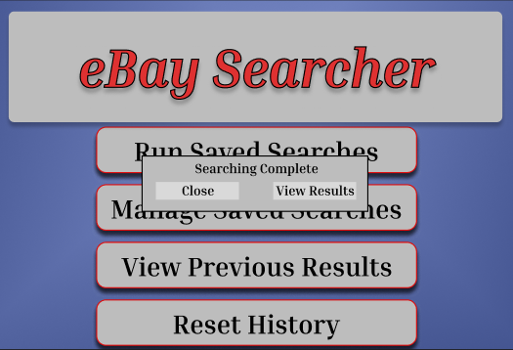The eBay website returns search results. The system translates the results into a set. The system discards results that exist in its internal history. The system adds the new results to its internal history. The system adds the new results to its internal results log. The system notifies the user that the search is complete.
    - 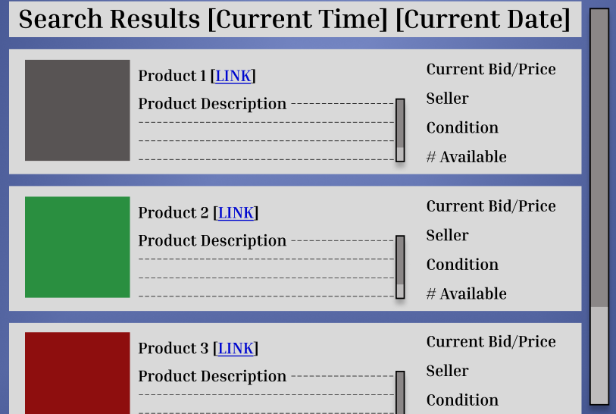The user hits the “View Results” button. The system displays the results in a new window.
  + Alternate Course(s)
    - If the user hits “Cancel Searches” before the system finishes running them, the system stops in the middle and discards the interim results.
    - 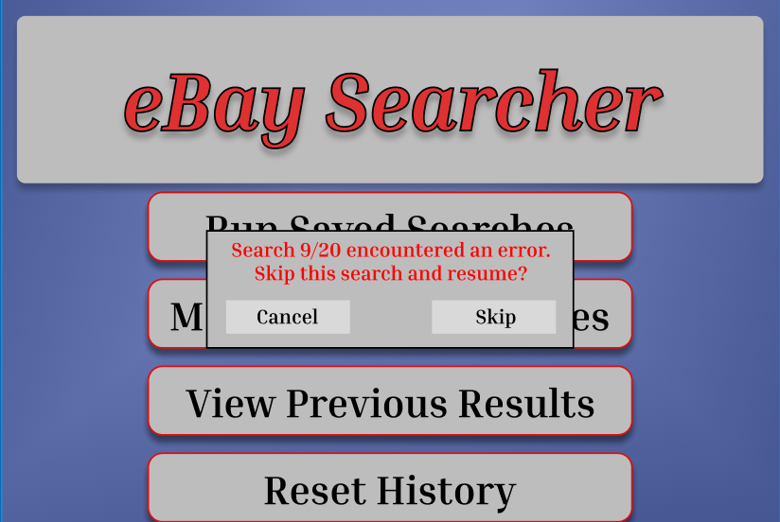If the system encounters an error with one or more searches, display a message to that effect and ask the User if they would like to continue.
      * + If the user selects Cancel, the systems cancels the ongoing search and discards the interim results.
        + If the user selects Skip, the system ignores the error and resumes the search with the next saved search
    - 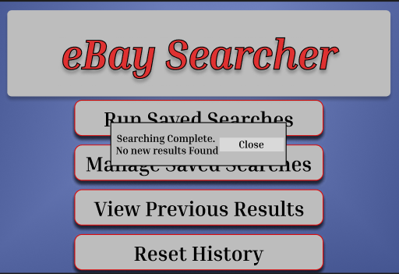If there are no new results, the system displays a message to that effect and returns to the main window.
    - If the user hits the “Close” button. The system does not display the search results yet.
* Reset Internal History
  + Basic Course
    - 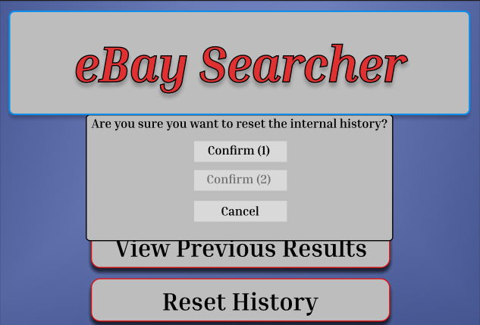The User hits the “Reset History” button. The system asks the user for confirmation twice.
    - The user confirms both times. The system wipes its internal result history, including prior search results. Subsequent searches will show results as if no results had been seen before.
  + Alternate Course(s)
    - If the user does not confirm twice, the system does not reset the history and returns to the main window.
* View Previous Results
  + Basic Course
    - The user hits the “View Previous Results” button.
    - 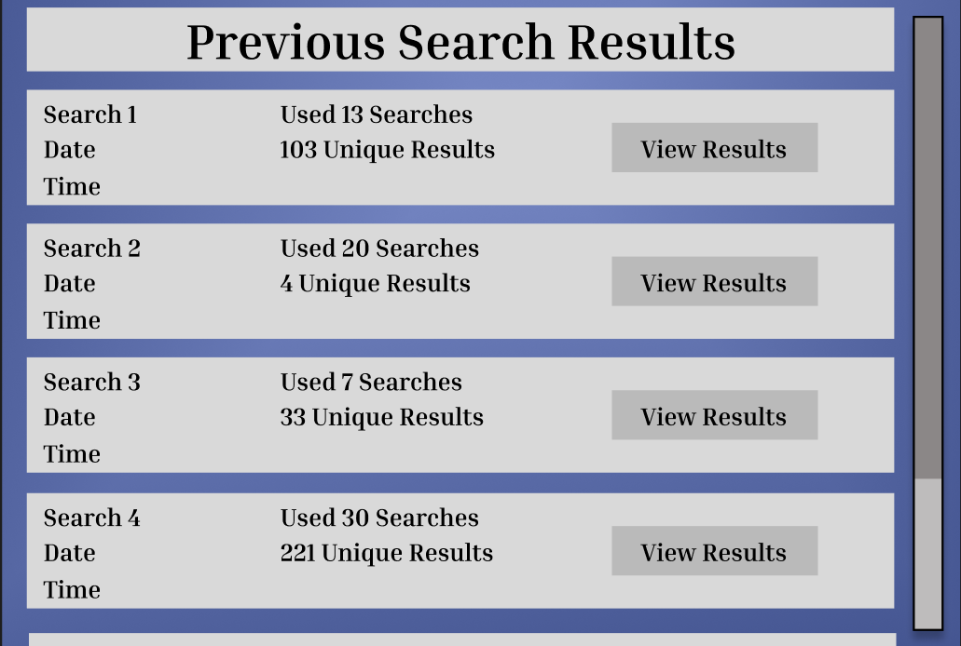The system loads its internal result log and displays a new window. The system displays a log of all completed “Run Search” operations.
    - 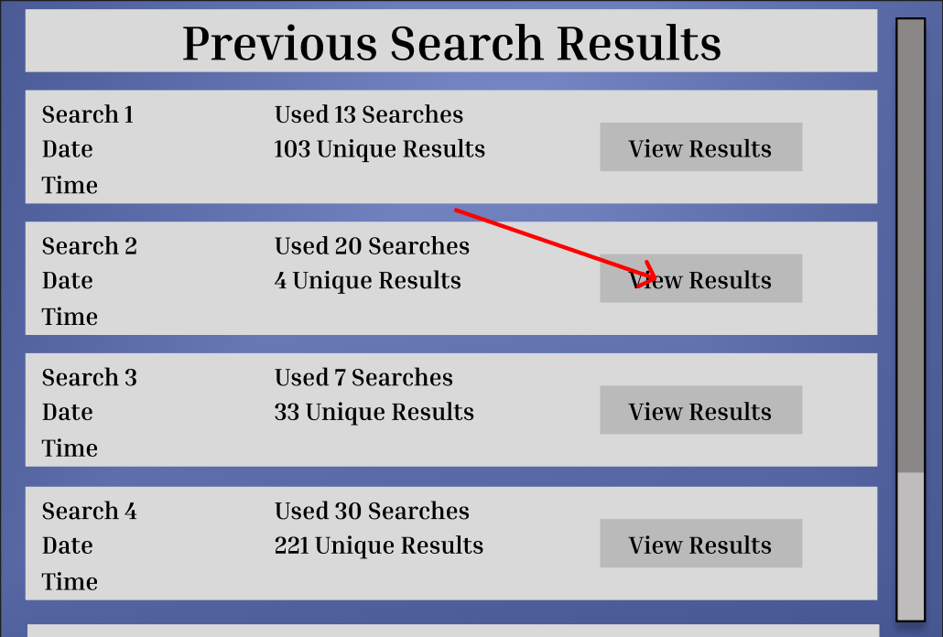The user selects a result to view.
    - The system displays the result window for that search operation.
  + Alternate Course(s)
    - 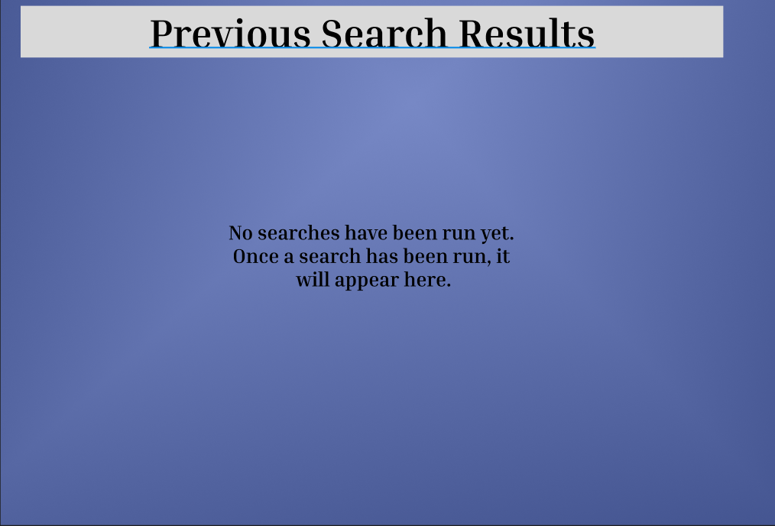If no search operations have been run, display a message to that effect.

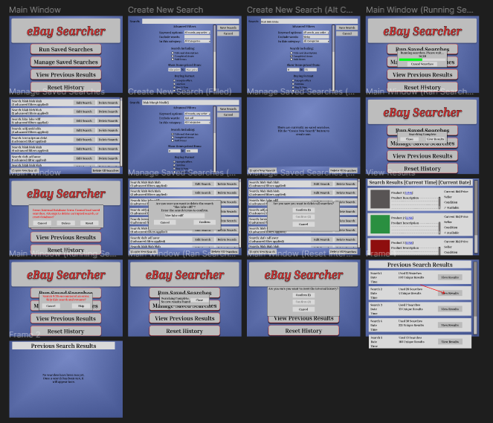FOR REFERENCE: Final Prototyping Environment